~**Asia-China-Mirror-4 Leaf-16 Arc-4 Boss**

- 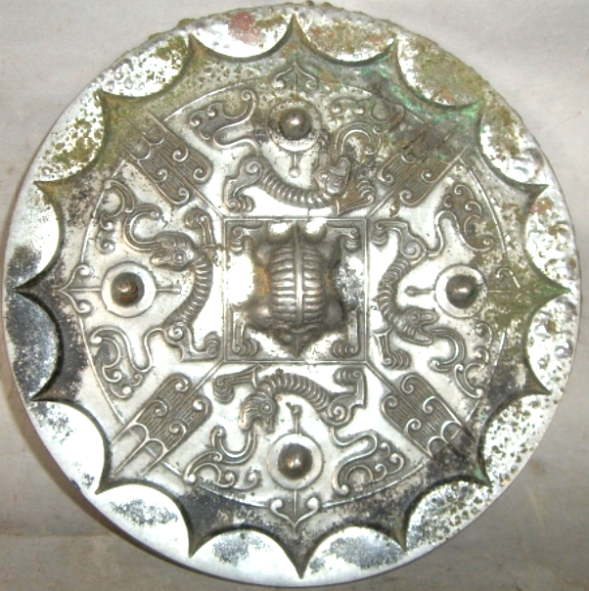

4 Leaf-16 Arc-4 Boss Mirror with 'caoye' design, 2nd century BCE (Karlgren 1941:111), Atlantica Collection.

**Similar to Karlgren (1941, pl. 78, no. 13: "Knob and quatrefoil...; square central band [missing an inscription in our example], at corners of the central band ... brush-like petals; four bosses, under them dragons and above them simple petals." White metal, 16 continuous rim arcs, inner square and 4 leaves (*caoye*); 4 bosses at the cardinal directions, dragon (?) at the central knob. Four leaf, 16 arc and 4 boss configurations, which appeared at the end of the Warring States period, depict a cosmological scheme: the arcs suggest the sun's cycle, and the bosses indicate the cardinal points of the compass to point the way.**

**The four designs between the four cardinal bosses have been interpreted as "brush like petals (Karlgren 1941:112), "birds with spread wings" (Swallow (1977:44) and as "a 'caoye', or grass and leaf, pattern ... defined by the symmetrical motif resembling an ear of corn" (Menzies 2003:74). It has also been suggested that the leaf designs may be derived from the Shang *taotie* 饕餮 , all-devouring beast, suggesting that the viewer is being engaged in a mysterious communication with Shang Ti (heaven's order). The *taotie* motif is actually picked up by dragons that wind around the four cardinal bosses. The central square motif recalls a Ch'in brick according to Swallow (1977:44).**

References: Karlgren, Bernard . 1941. *Huai and Han*. BMFEA, 13. Stockholm.

Menzies, Jacqueline . 2003. "Mirror with 'caoye' design [1[st century BCE](http://www.artgallery.nsw.gov.au/collection/search/?period=china.han-dynasty-206-bce-220-ce)]," *The Asian Collections: Art Gallery of*

Nakano, Toru. 1994. *Bronze Mirrors from Ancient China* ([Hong Kong]: Orientations.

*New South Wales.* London : Thames & Hudson.

Swallow, Robert W. 1977. *Ancient Chinese bronze mirrors*. Rev. and enlarged ed. by Fred Belcher. Ann Arbor: Ars Ceramica, Ltd.

National Palace Museum. [1986] *Gu gong tong jing te zhan tu lu* = Catalogue of the special exhibition of bronze mirrors in the National Palace Museum. Taipei: Guo li go gu gong bo wu yuan, Minguo 75.